AWS EC2 Instance

1. Login page to AWS

* <https://aws.amazon.com/>
* Click on Sign In to the Console and login with the credentials

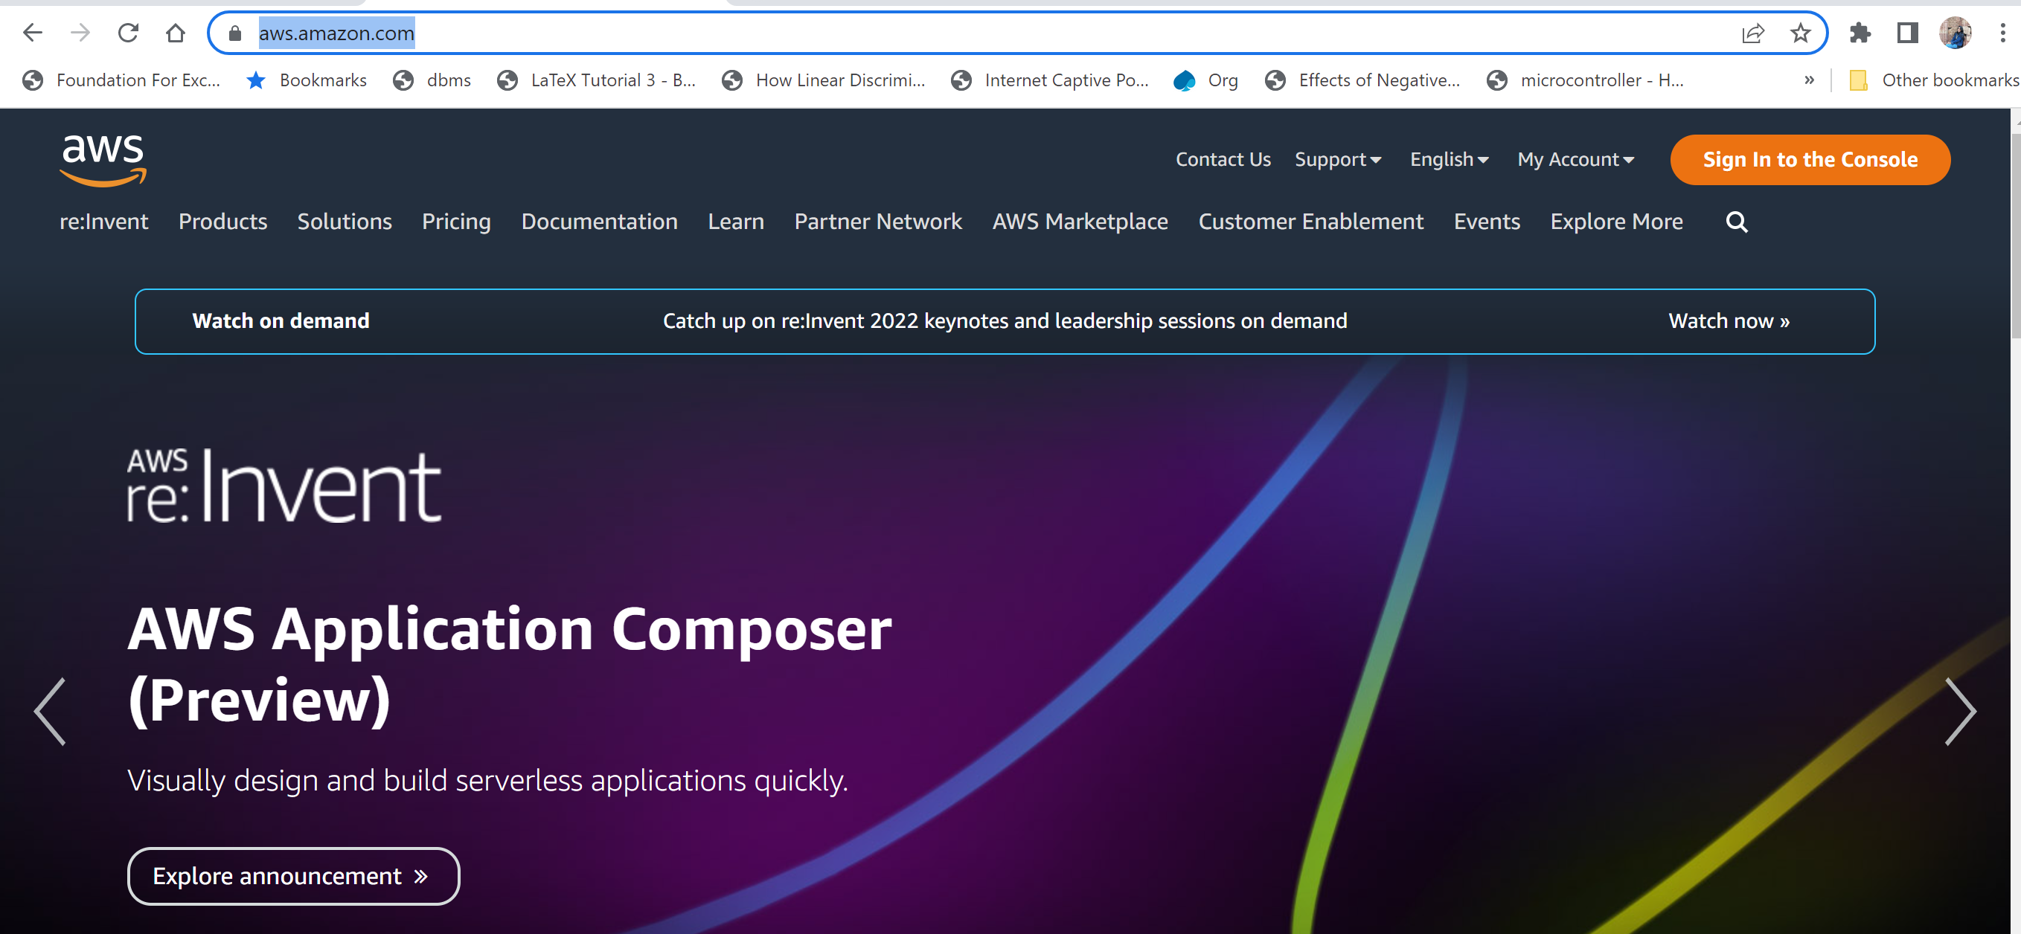

1. To Navigate to EC2 Instance Dashboard: Click on Services -> All Services -> EC2

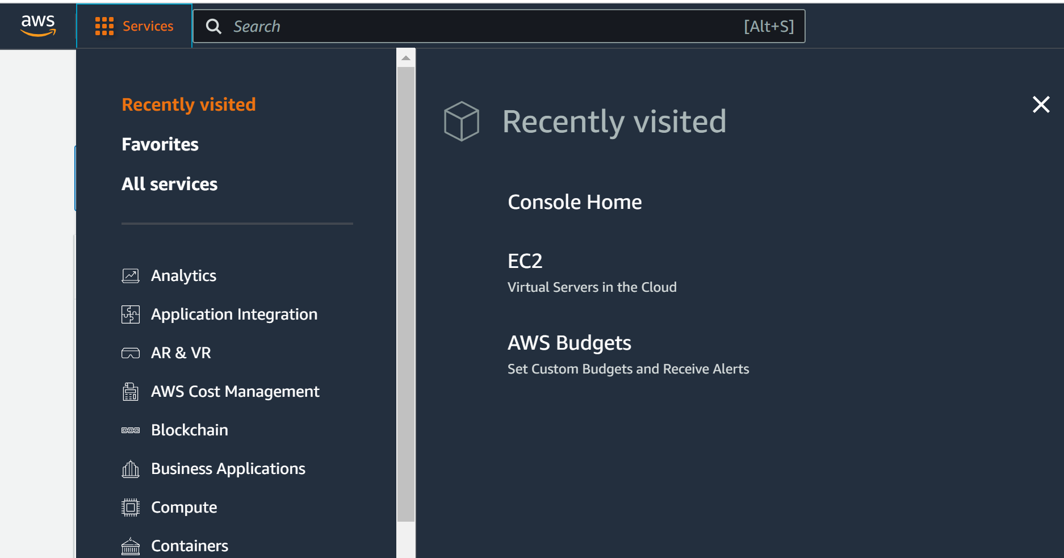

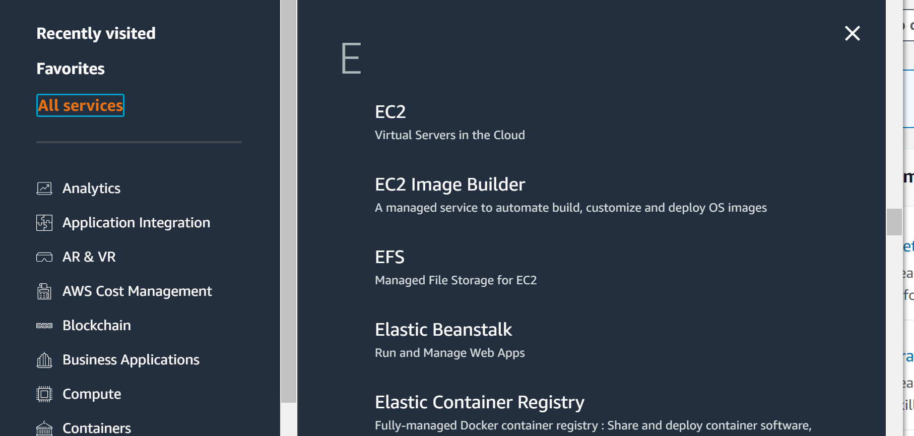

1. To launch an EC2 Instance :

* Click on Launch Instance

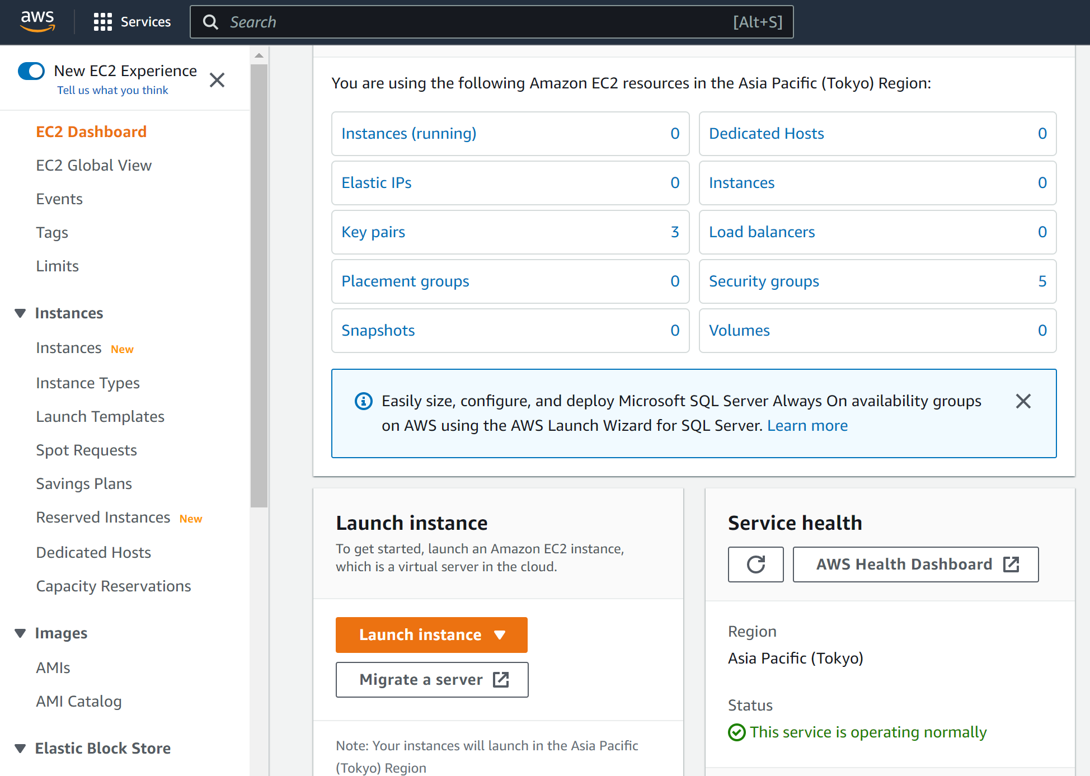

* Enter the name of the EC2 machine , and select the Red hat from Application and OS Images. (Free tier)

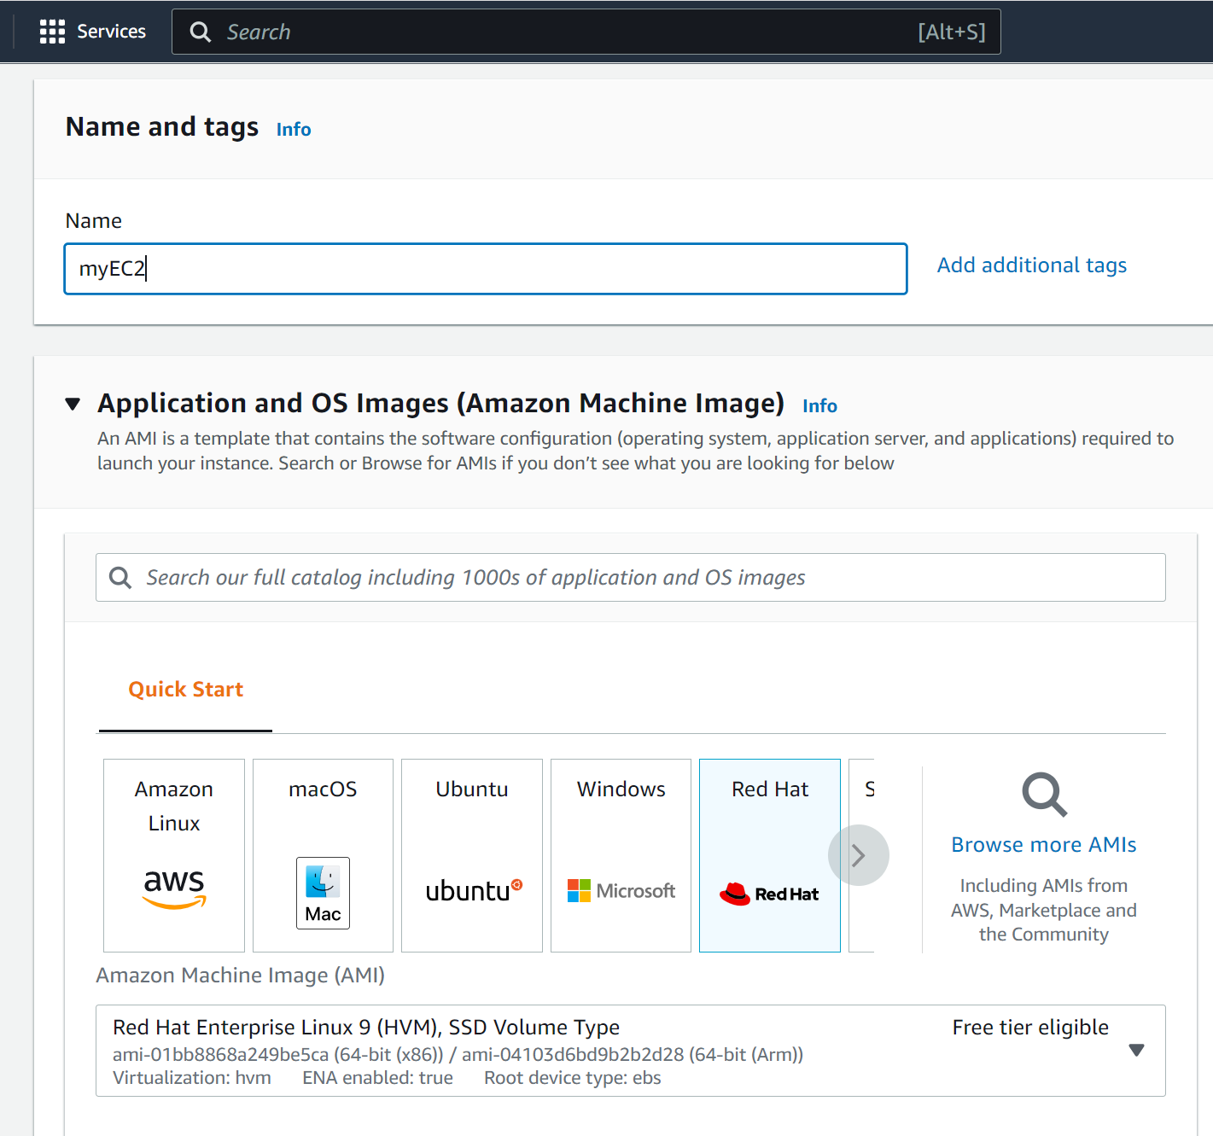

* Create a key pair

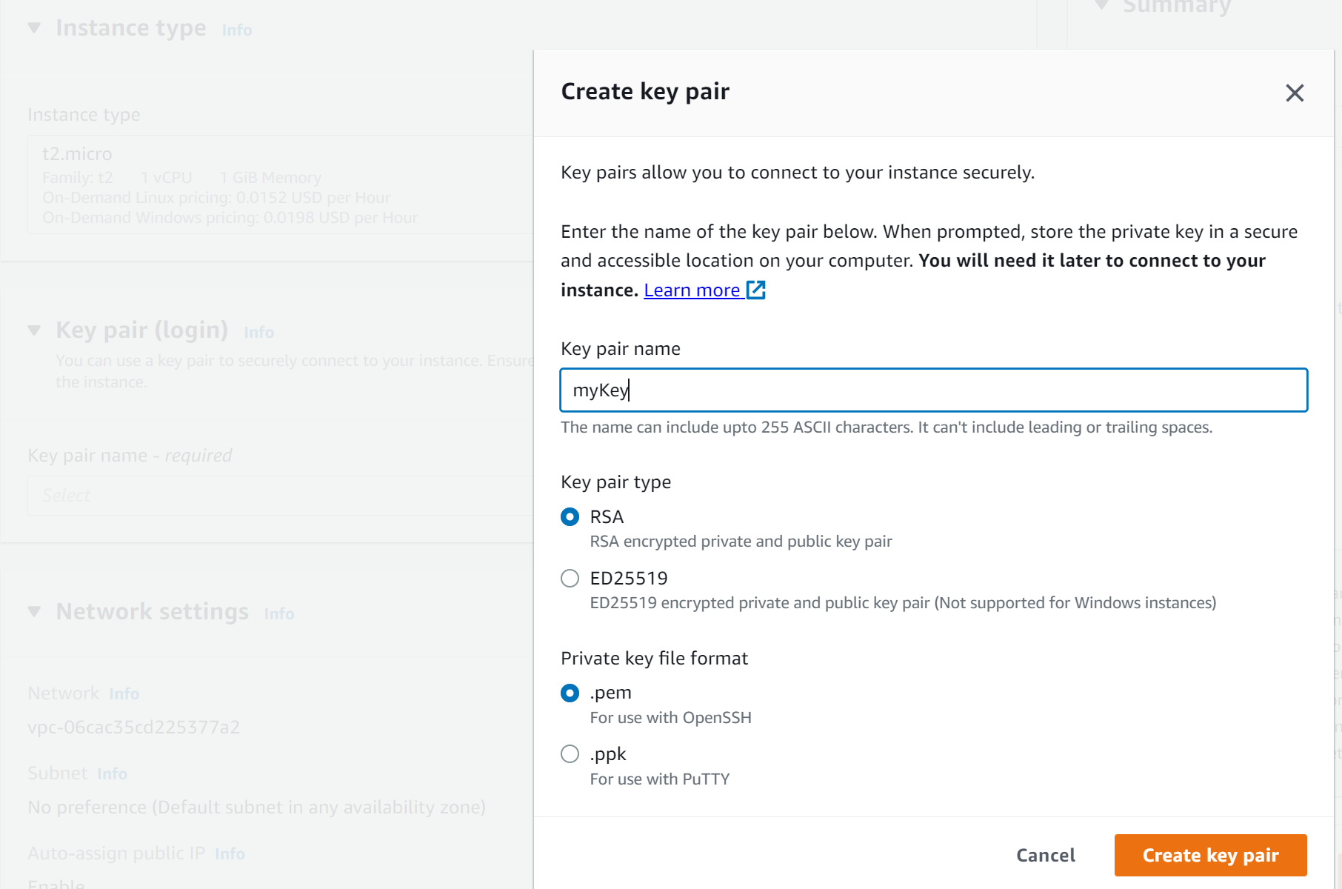

* Click on Launch Instance

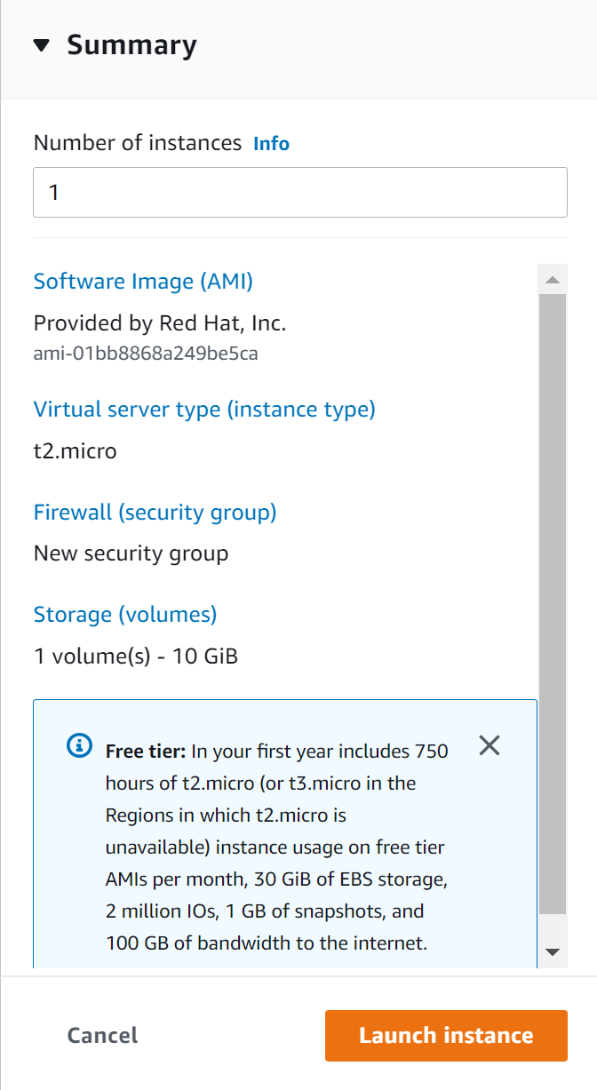

* Click on View all Instances to see the created EC2 Instance

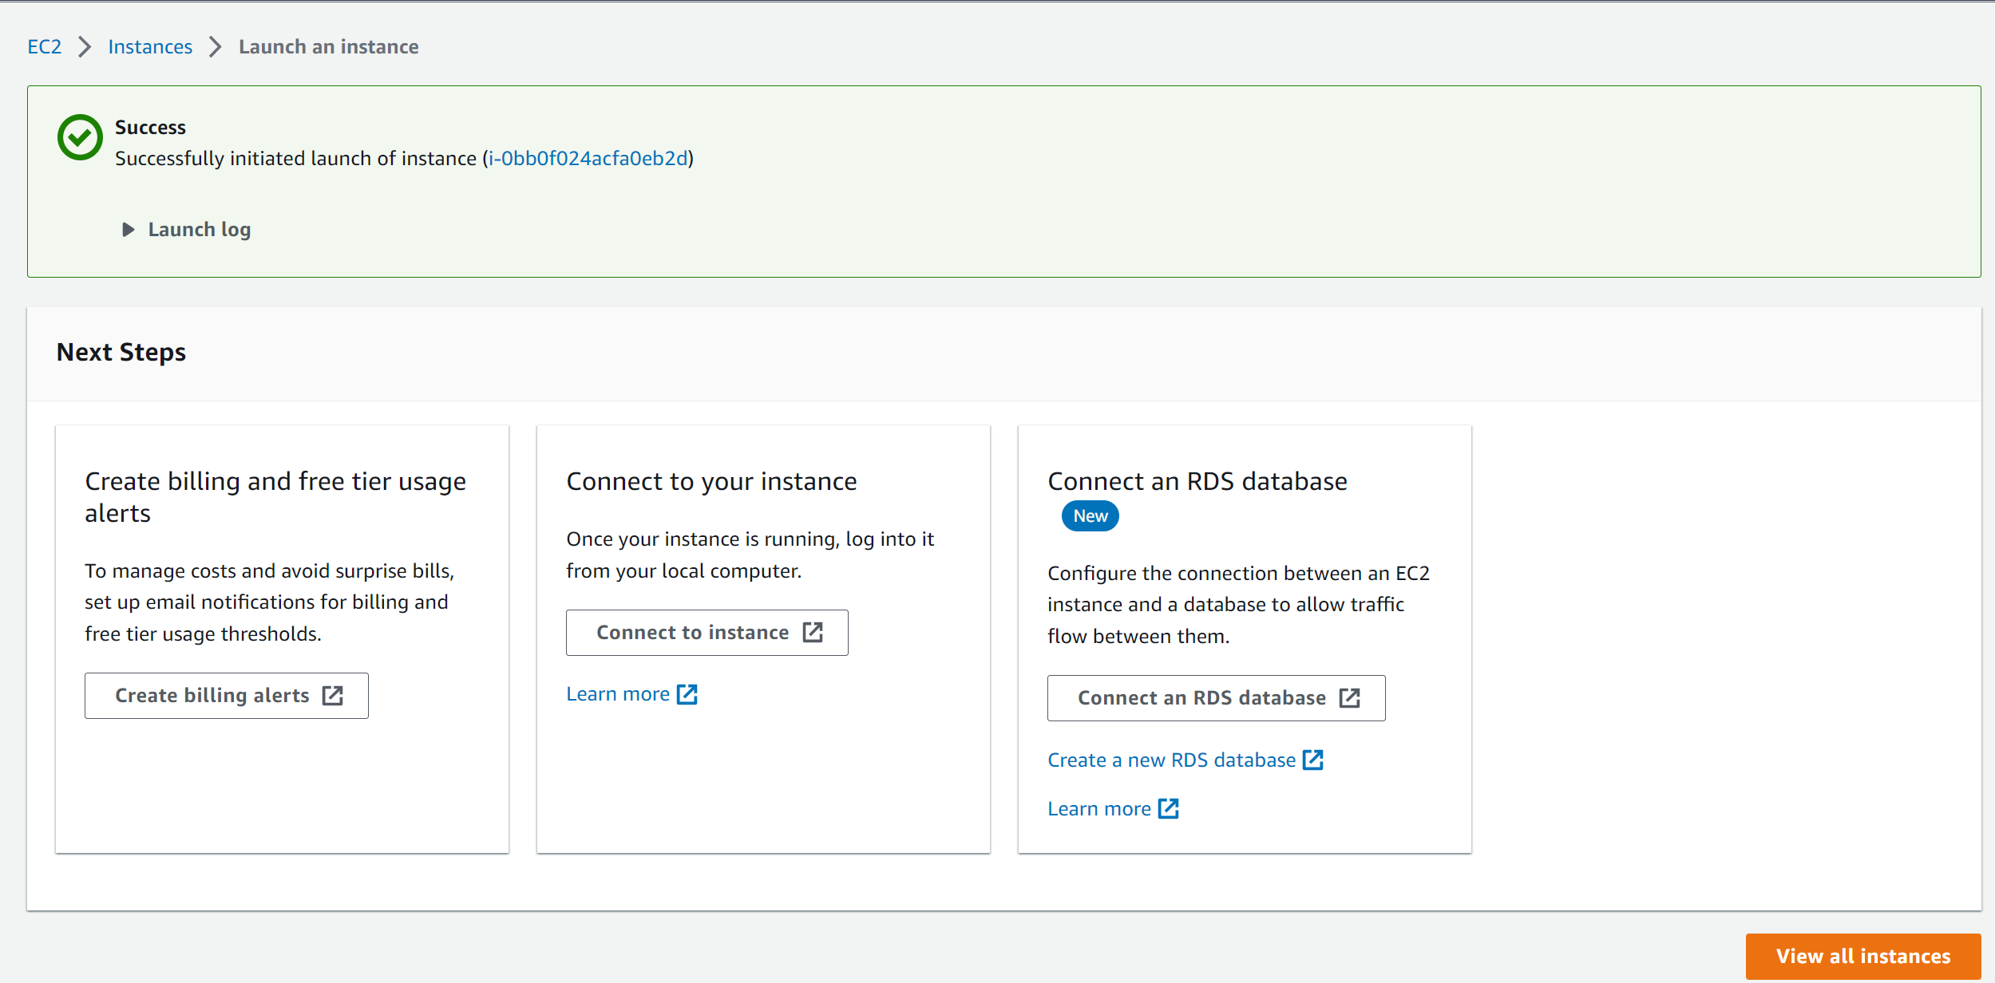

* In the EC2 Dashboard verify the status of the instance (Instance state should be Running and Status check should be passed )

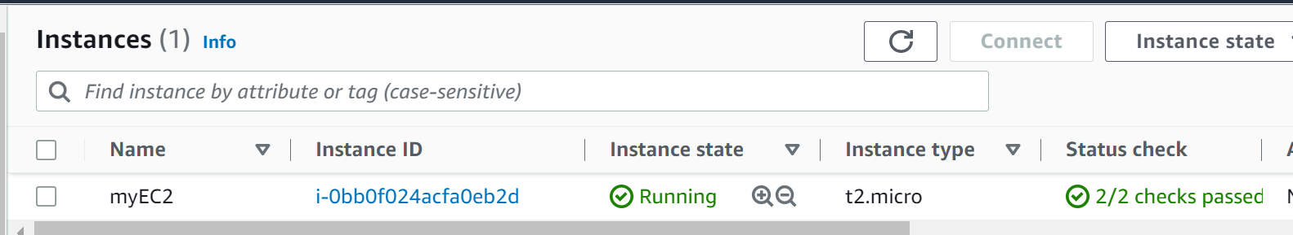

1. To login to the EC2 instance created

* Click on Instance ID

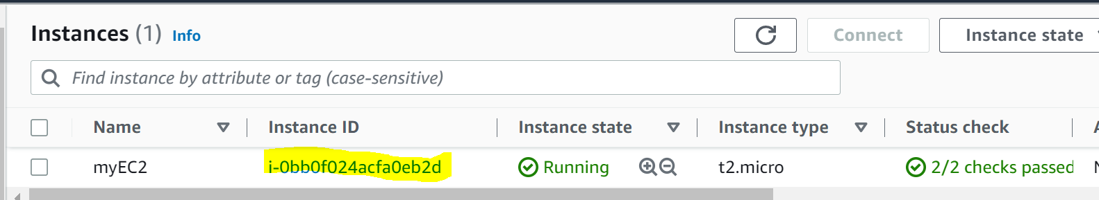

* Click On Connect

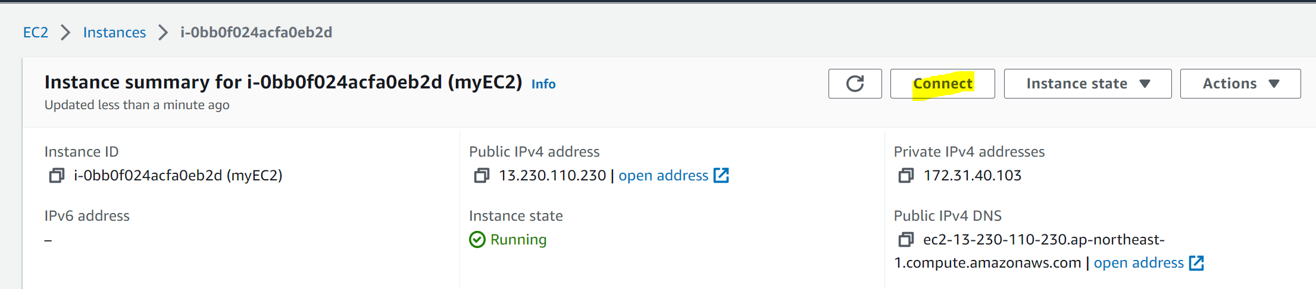

* Click on SSH Client and follow the steps from there

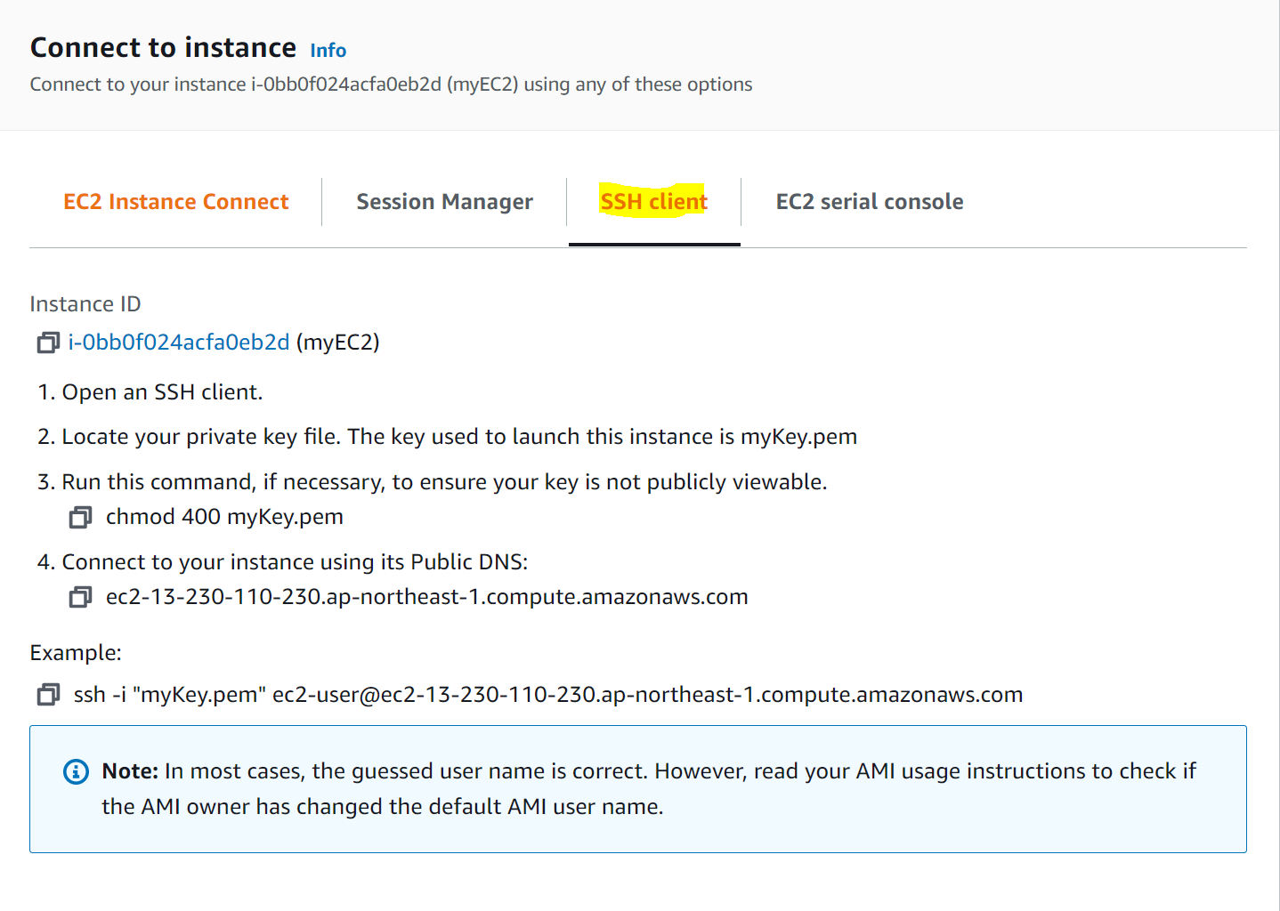

* Locate the Key file

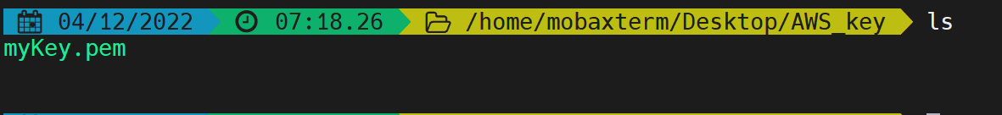

* Run command “chmod 400 myKey.pem

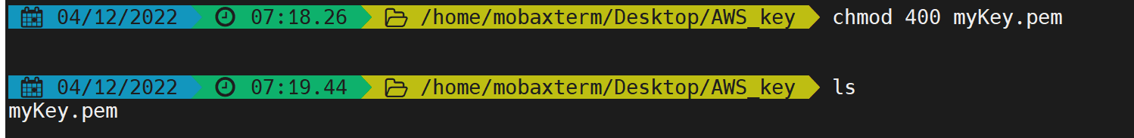

* Connect to the instance using “ssh -i "myKey.pem" [ec2-user@ec2-13-230-110-230.ap-northeast-1.compute.amazonaws.com](mailto:ec2-user@ec2-13-230-110-230.ap-northeast-1.compute.amazonaws.com)”

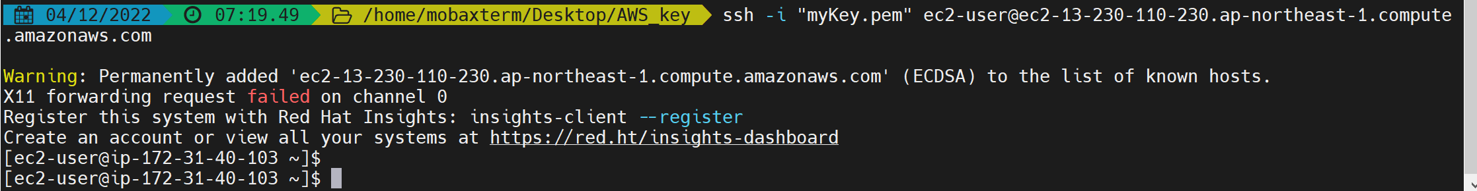

1. Execute few linux commands

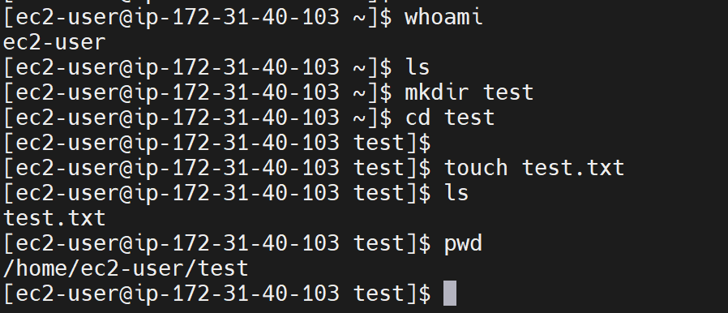

1. To Terminate the EC2 Instance and to exit from the ssh client

* Click on exit in the client

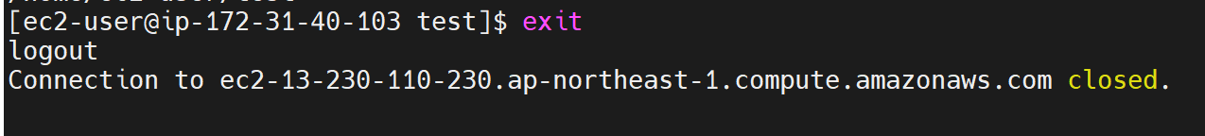

* Navigate to EC2 Dashboard and click on Terminate Instance

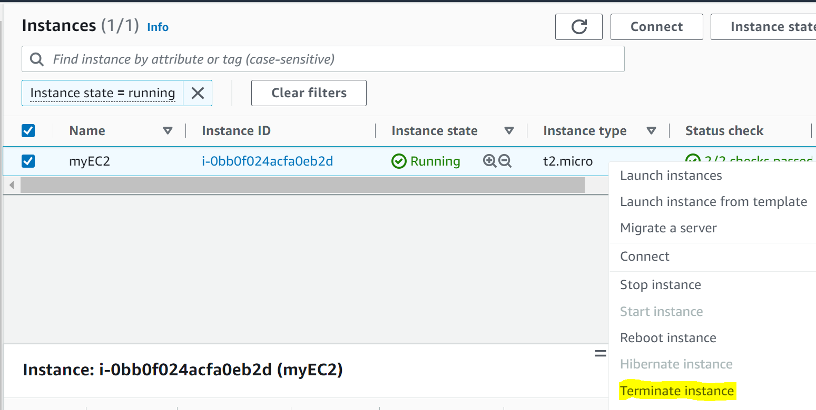

* Verify the Instance state as Terminated

